Enable httpbin sample

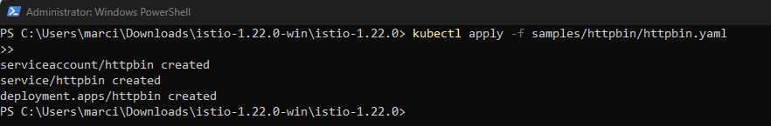

Create destination rule

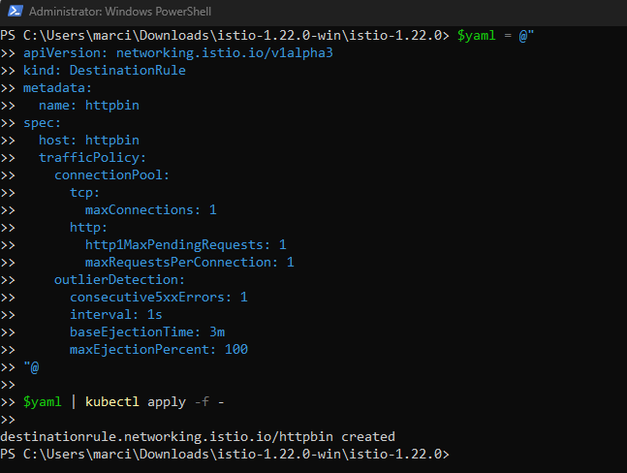

Confirm rule exists

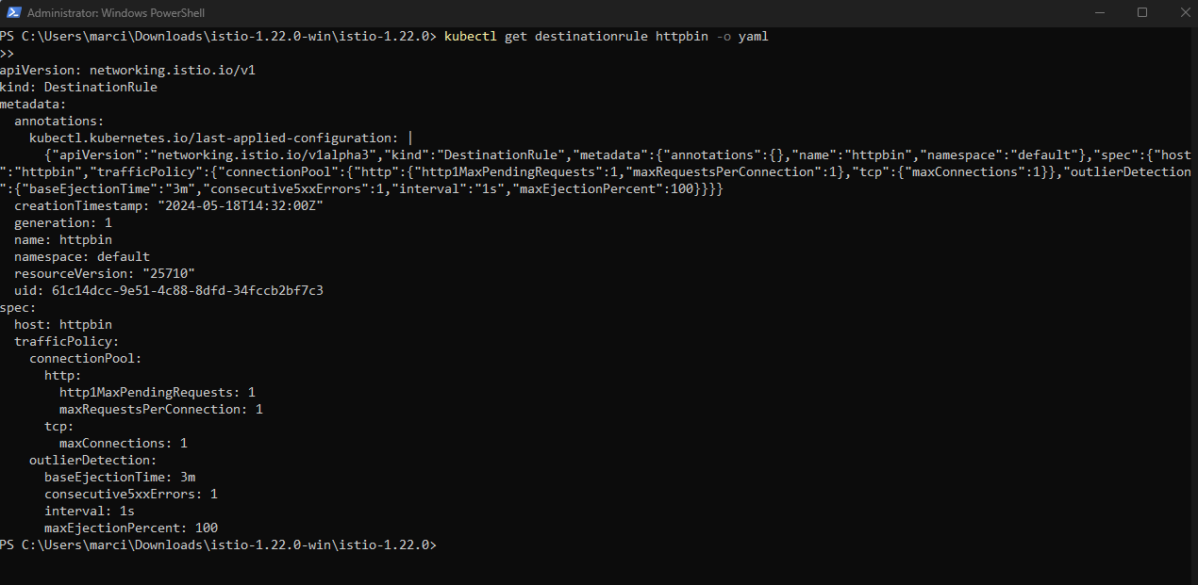

Create http sample client

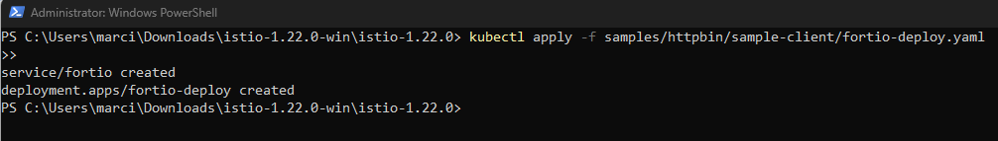

Make a curl call from fortio

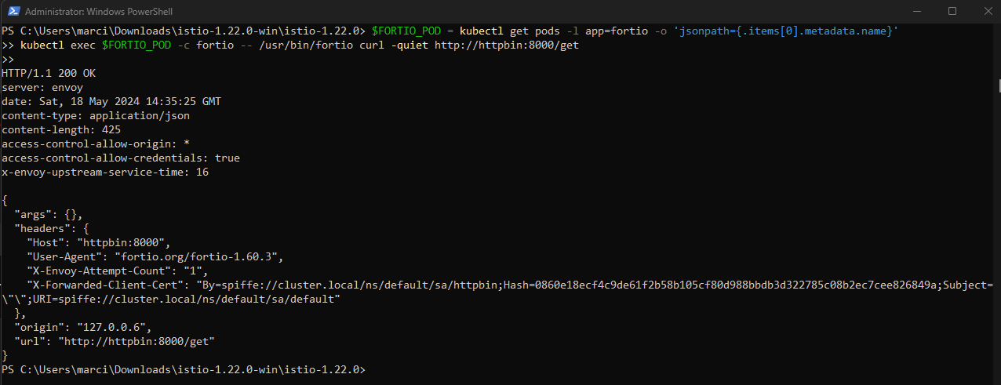

Send a heavy request load to cause problems

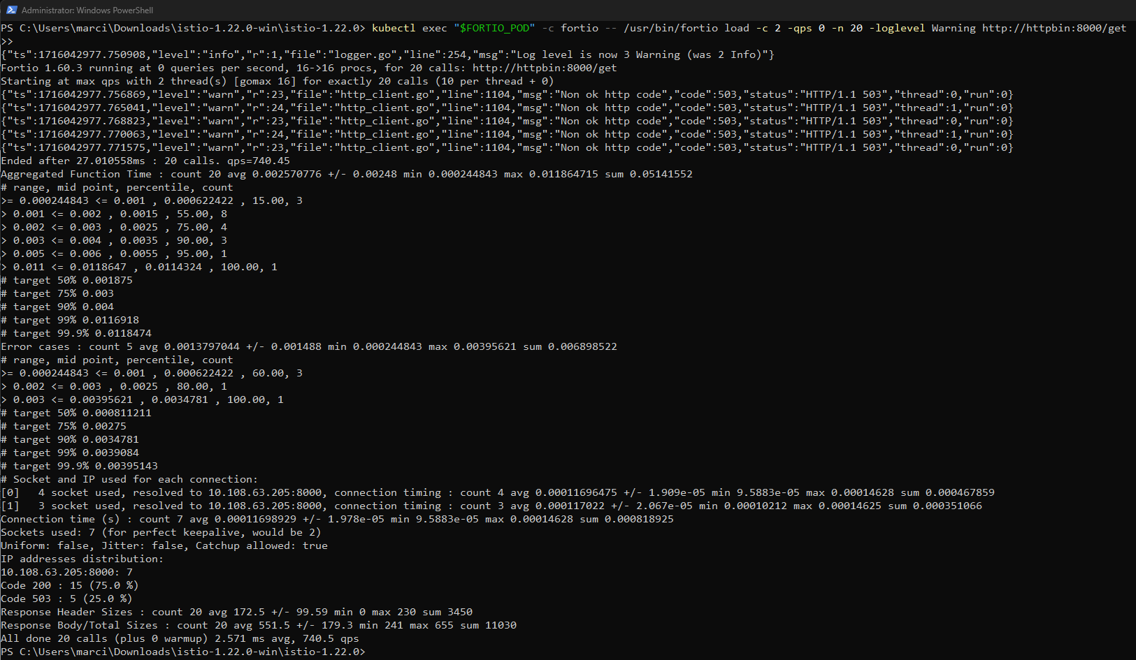

15 Requests of 20 passed

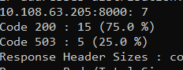

After increasing to 3 connections with 30 requests,70% (21)failed

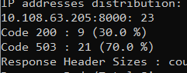

Query ‘istio-proxy’ to check statistics

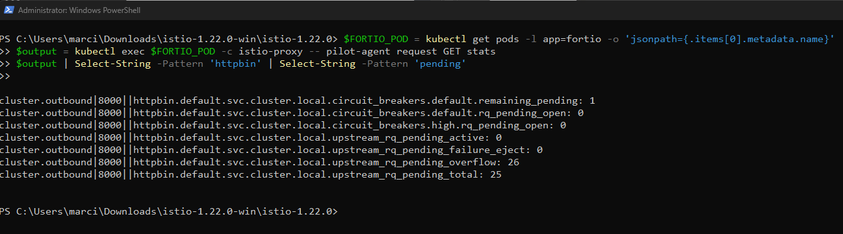

Remove rule

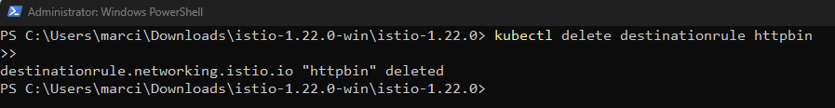

Kill HTTP Client & Service

